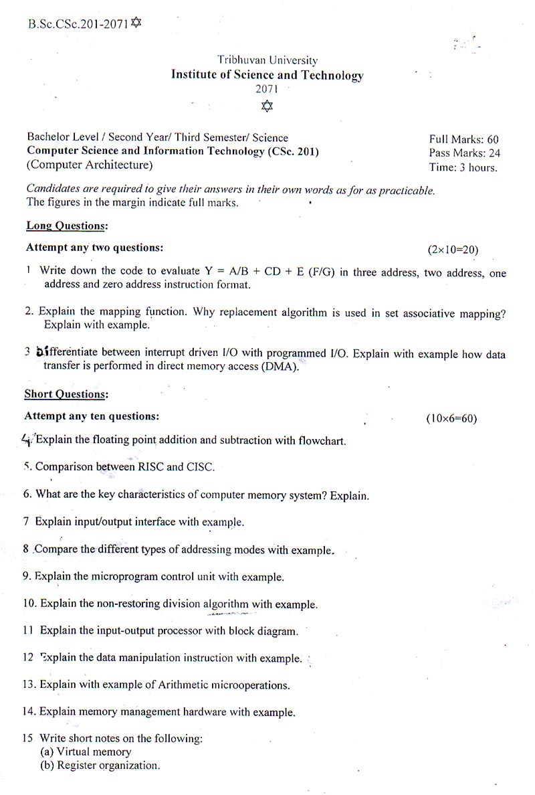

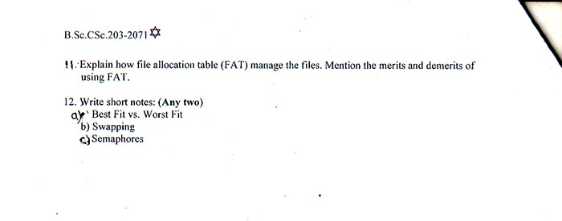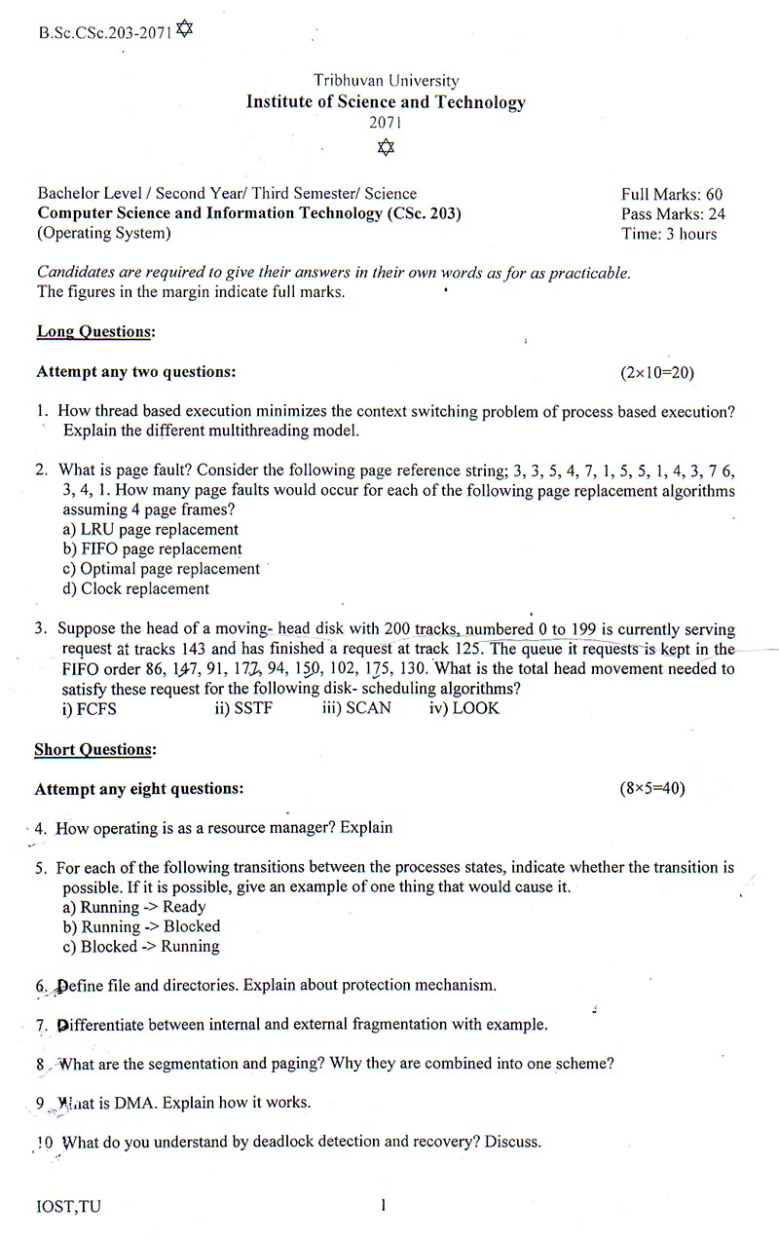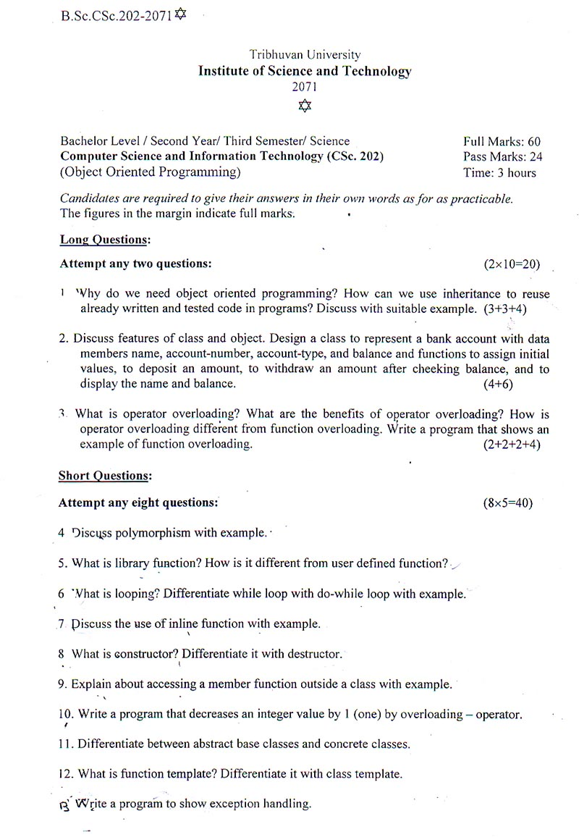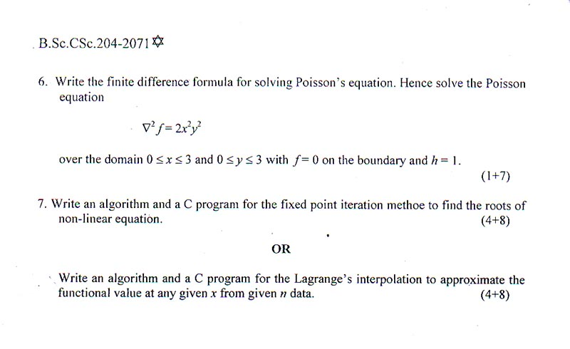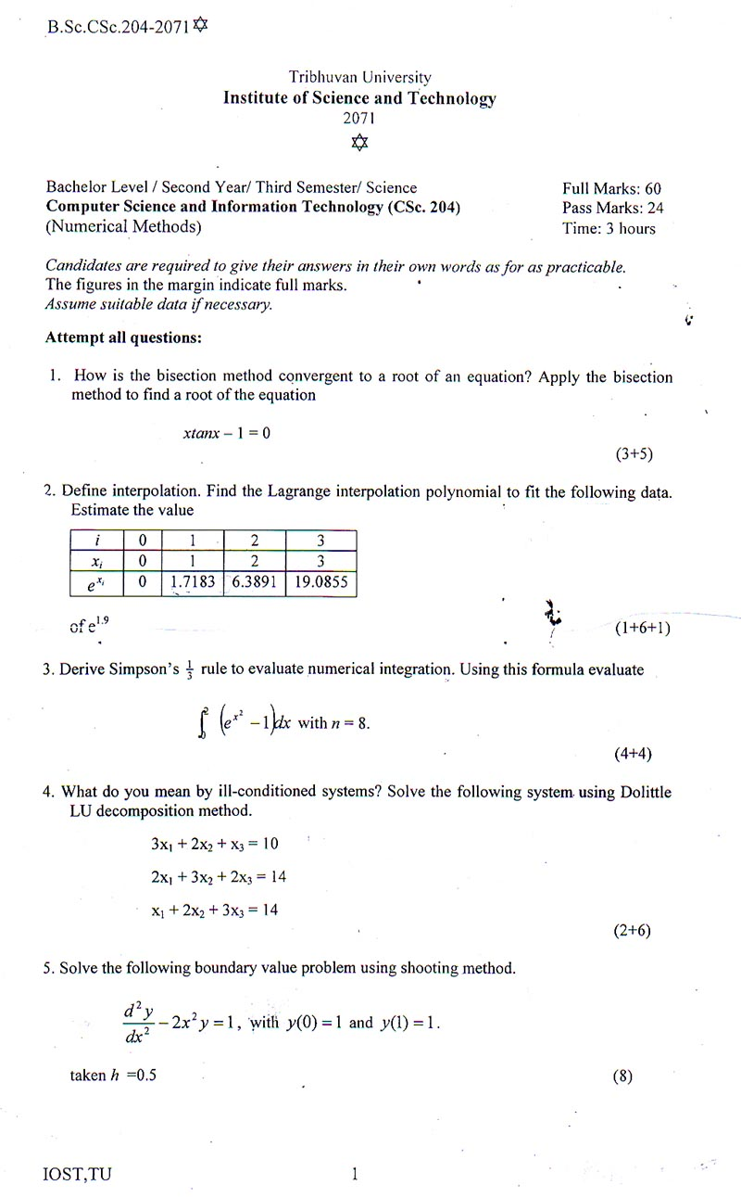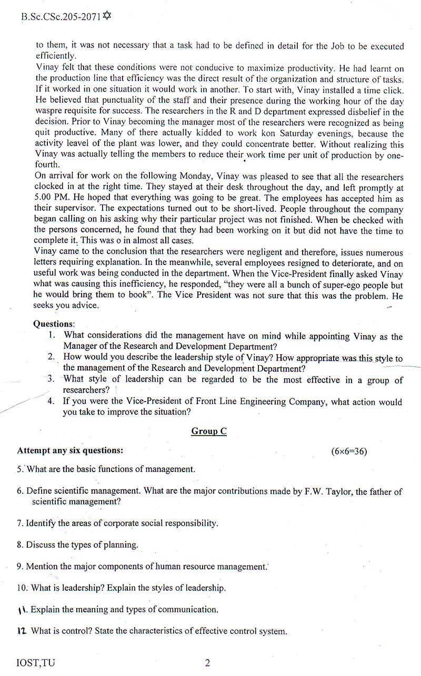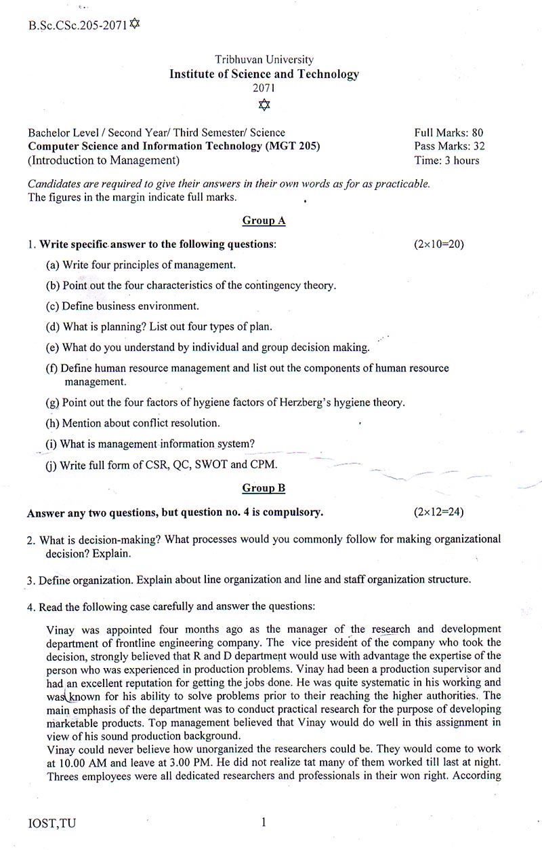

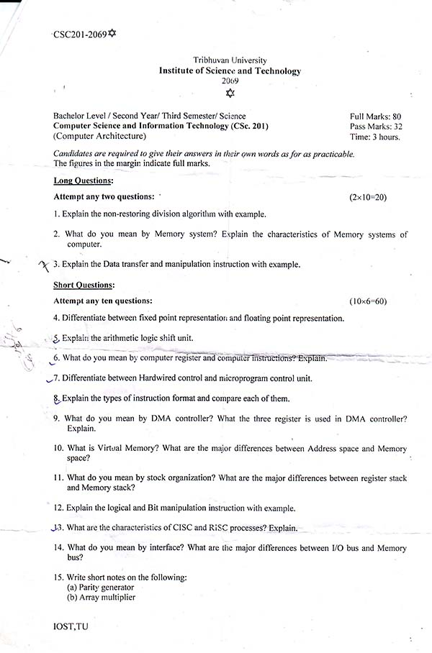

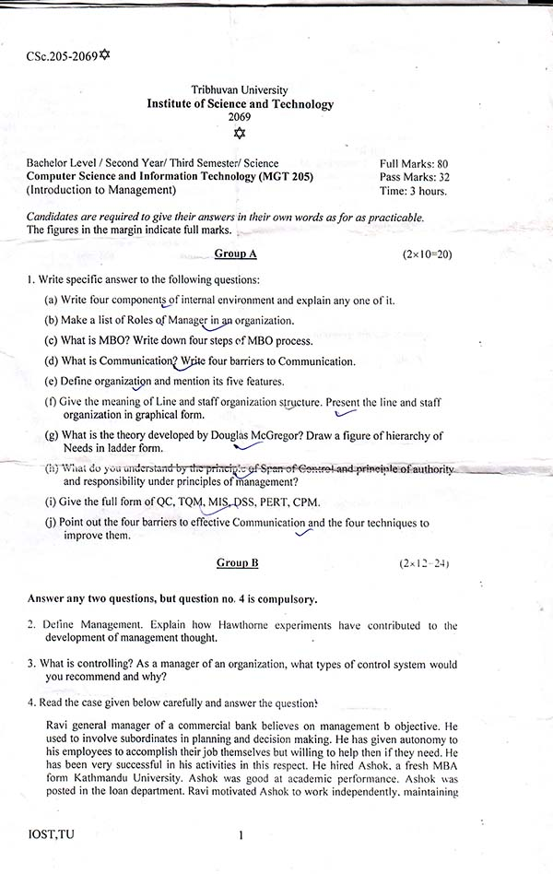

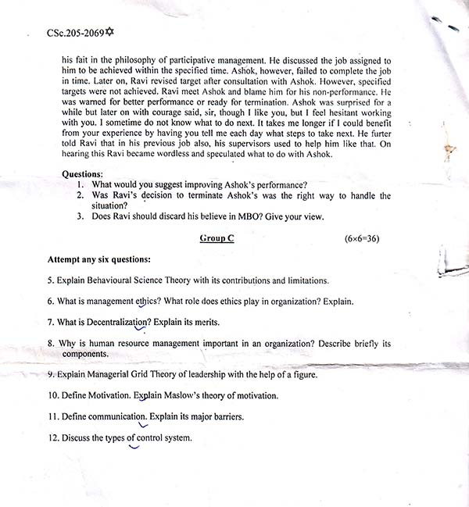

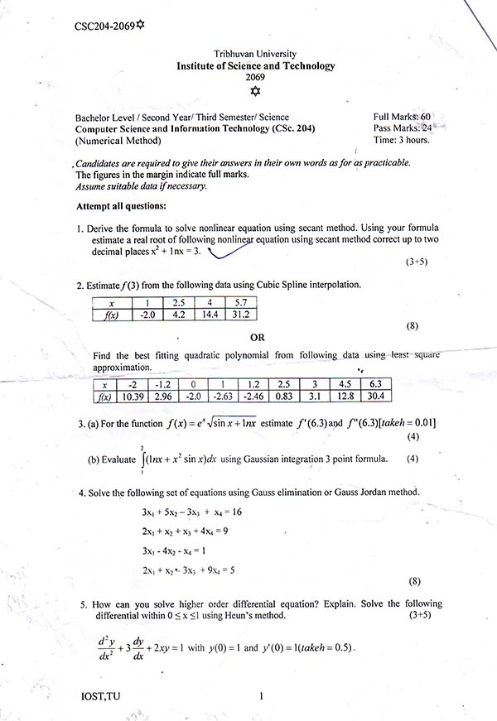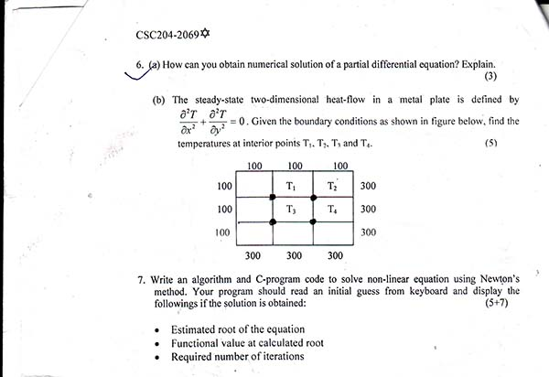

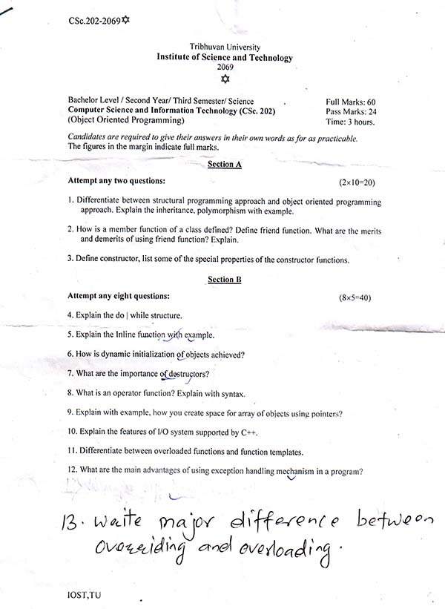

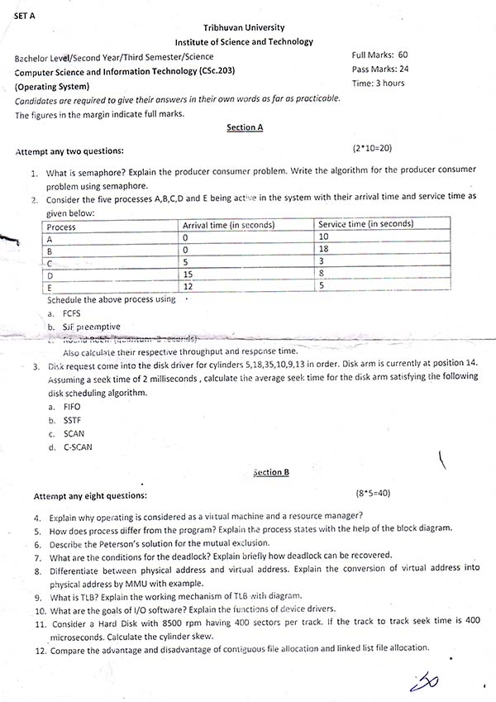

1CSc. 201-2068 IOST, TU **Downloaded from: http://www.bsccsit.com**

**Tribhuvan University**

**Institute of Science and Technology**

**2068**

 

Bachelor Level/ Second Year/ Third Semester/Science Full Marks: 80

**Computer Science and Information Technology (CSc 201)** Pass Marks: 32

(Computer Architecture) Time: 3 Hours

*Candidates are required to give their answers in their own words as far as practicable.*

The figures in the margin indicate full marks.

**Long Questions:**

**Attempt any two questions:** (2x10=20)

1. Explain the restoring division algorithm with example.

2. What do you mean by I/O interface? Explain the I/O bus and Interface module.

3. What do you mean by memory organization? Explain the memory management hardware with example.

**Short Questions:**

**Attempt any ten questions:** (10x6=60)

4. Explain the error detection code with example.

5. Differentiate between logic microoperations and shift microoperations.

6. Explain the I/O instruction with example.

7. What do you mean by memory mapping? Explain.

8. What do you mean by control memory? Explain the microinstructions and microoperation format.

9. What do you mean by addressing modes? Differentiate between indexed addressing modes and base register addressing mode.

10. Explain the Booth algorithm. Multiply 3 x 5 using booth algorithm.

11. Differentiate between isolate and memory mapped I/O.

12. Explain the I/O processor with block diagram.

13. Explain data transfer instruction with example.

14. Differentiate between RISC and CISC processor.

15. Write short notes on the following:

(a) Interrupt cycle

(b) DMA

1CSc. 201-2067 IOST, TU **Downloaded from: http://www.bsccsit.com**

**Tribhuvan University**

**Institute of Science and Technology**

**2067**

 

Bachelor Level/ Second Year/ Third Semester/Science Full Marks: 80

**Computer Science and Information Technology (CSc 201)** Pass Marks: 32

(Computer Architecture) Time: 3 Hours

*Candidates are required to give their answers in their own words as far as practicable.*

The figures in the margin indicate full marks.

**Long Questions:**

**Attempt any two questions: (2x10=20)**

1. Explain the Micro program sequence with example.

2. Explain with example of Data manipulation instructions.

3. Explain the non-restoring Division algorithm, flow chart hardware implementation with example.

**Short Questions:**

**Answer any ten questions: (10x6=60)**

4. What do you mean by instruction format? Explain.

5. Differentiate between Hardwired and Micro program control unit.

6. What do you mean by logic micro-operations?

7. Differentiate between direct and indirect addressing modes.

8. Explain with example of Data transfer instructions.

9. What are the major differences between RISC and CISC architecture.

10. Explain the subtraction algorithm with signed 2’s compliment.

11. Differentiate between isolated I/O and Memory Mapped I/O.

12. What is DMA transfer? Explain.

13. What is the role of input-output processor (IOP) in computer system? Explain.

14. What is memory management hardware? Explain.

15. Write short notes on the following:

a. Sequential memory hierarchy.

b. Random memory hierarchy.

1CSc. 201-2066 IOST, TU **Downloaded from: http://www.bsccsit.com**

**Tribhuvan University**

**Institute of Science and Technology**

**2066**

 

Bachelor Level/ Second Year/ Third Semester/Science Full Marks: 80

**Computer Science and Information Technology (CSc 201)** Pass Marks: 32

(Computer Architecture) Time: 3 Hours

*Candidates are required to give their answers in their own words as far as practicable.*

The figures in the margin indicate full marks.

**Long Questions:**

**Attempt any two questions: (2x10=20)**

1. Explain the different types of addressing modes and compare each other.

2. What are the major differences between I/O bus and interface modules? What are the advantage and disadvantage of each?

3. What are the three possible modes to transfer the data to and from peripherals? Explain.

**Short Questions:**

**Answer any ten questions: (10x6=60)**

4. Differentiate between parity checker and parity generator.

5. What do you mean by shift micro-operations? Explain.

6. Explain the computer instruction with example.

7. Mention the type of interrupt and explain it.

8. What do you mean by field decoding? Explain.

9. Write down the following equation in three address, two address and one address instruction.

( ) ( ⁄)

10. Explain the characteristics of RISC and CISC.

11. Explain the booth algorithm with example.

12. What is the main function of DMA? Mention the three points DMA configurations.

13. What are the different types of I/O commands? Explain.

14. Differentiate between associative page table and replacement.

15. Write short notes on the following:

a. Memory space

b. Address space

1CSc. 205-2068 IOST, TU **Downloaded from: http://www.bsccsit.com**

**Tribhuvan University**

**Institute of Science and Technology**

**2068**

 

Bachelor Level/ Second Year/ Third Semester/Science Full Marks: 60

**Computer Science and Information Technology (MGT 205)** Pass Marks: 24

(Introduction to Management) Time: 3 Hours

*Candidates are required to give their answers in their own words as far as practicable.*

The figures in the margin indicate full marks.

**Group A** (1x10=10)

1. Write specific answer to the following questions:

(a) Who is credited for Hawthorne Studies?

(b) Write a definition of organization.

(c) What is Total Quality Management?

(d) Write down the function of HRM.

(e) What do you understand by Principle of Unity of Command?

(f) List three advantages of Line and Staff Organization.

(g) Write any three Hygiene Factors as described in Herzberg‟s Motivation Hygiene Theory.

(h) What is conflict?

(i) What is control?

(j) What can be understood by „9, 9‟ in explaining Managerial Grid Theory?

**Group B** (2x10=20)

**Answer any two questions, but question no 4 is compulsory.**

2. Explain the System Approach in detail.

3. Discuss in detail the types of planning.

4. Read the case given below carefully and answer the question:

Mr. Thapa is a Branch Manager of Development Bank. It is a regional bank starting its operation from Surkhet. The bank has its clear policies; the Executive Chairperson of the bank provides close supervision; the salary given to Mr. Thapa meets his daily requirements and other conditions are found satisfactory.

Mr. Thapa usually comments on his work environment as follows: 1CSc. 205-2068 IOST, TU **Downloaded from: http://www.bsccsit.com**

“I don‟t like this work as the executive use us to earn money and forbid us to grow. We are being used as a machine and nobody cares about what I want and what I like. They are only concerned to earn money.”

**Questions:** What do you understand by motivation? Explain analyzing the case which motivation theory helps describing Mr. Thapa‟s behavior.

**Group C** (6x5=30)

**Attempt any six questions:**

5. What is Corporate Social Responsibility? Briefly discuss.

6. Describe the steps in planning.

7. What is programmed and non-programmed decision making? Explain briefly.

8. Describe how conflict can be resolved.

9. Describe the communication process.

10. Why MIS is important for organization?

11. Describe the components of technological environment.

12. What is MBO? Explain briefly.

1CSc. 205-2067 IOST, TU **Downloaded from: http://www.bsccsit.com**

**Tribhuvan University**

**Institute of Science and Technology**

**2067**

 

Bachelor Level/ Second Year/ Third Semester/Science Full Marks: 60

**Computer Science and Information Technology (MGT 205)** Pass Marks: 24

(Introduction to Management) Time: 3 Hours

*Candidates are required to give their answers in their own words as far as practicable.*

The figures in the margin indicate full marks.

**Group A** (1x10=10)

1. Write specific answer to the following questions:

a. What is the theory developed by Douglas McGregor?

b. What is leadership?

c. What is MBO?

d. What is programmed decision making?

e. What do you understand by the principle of order under principle of management?

f. List any three limitations of functional organization.

g. What is conflict?

h. What is quality control?

i. What is flexible plan?

j. What is Management Information System?

**Group B** (2x10=20)

**Answer any two questions, but question no 4 is compulsory.**

2. Discuss in detail the Corporate Social Responsibility?

3. Describe in detail the Managerial Grid Theory.

4. Read the case given below carefully and answer the question:

Mr. Sharma is a Section Officer of District Administration Office (DAO) of Kaski. He is transferred to DAO of Koshi. He is on the process of leaving Kaski.

Other employees of Koshi, who haven‟t seen Mr. Sharma before starts discussing about Mr. Sharma‟s character and qualities. They know much information about Mr. Sharma including his weakness in performing assigned tasks. 1CSc. 205-2067 IOST, TU **Downloaded from: http://www.bsccsit.com**

**Questions:** Describing the role of communication, explain how the employees of Koshi might have received the information of Mr. Sharma before his joining that office.

**Group C** (6x5=30)

**Attempt any six questions:**

5. Describe briefly the system concept in management.

6. What role do ethics play in organization? Briefly explain.

7. Describe why planning is important?

8. Describe what do you understand by decentralization?

9. What do you understand by hierarchy of planning?

10. Briefly describe the contribution of behavior science theory in management.

11. Discuss the functions of management.

12. Why quality assurance is important in management? Explain briefly.

1CSc. 205-2066 IOST, TU **Downloaded from: http://www.bsccsit.com**

**Tribhuvan University**

**Institute of Science and Technology**

**2066**

 

Bachelor Level/ Second Year/ Third Semester/Science Full Marks: 60

**Computer Science and Information Technology (MGT 205)** Pass Marks: 24

(Introduction to Management) Time: 3 Hours

*Candidates are required to give their answers in their own words as far as practicable.*

The figures in the margin indicate full marks.

**Group A** (1x10=10)

1. Write specific answers to the following questions:

(a) Who is the father of Scientific Management?

(b) Write a definition of management.

(c) What is the ethics in management?

(d) What is a system?

(e) What do you understand by the principle of Span of Control?

(f) List any three advantages of Line Organization.

(g) What physiological needs are as described by Maslow‟s Hierarchy of Needs?

(h) Write any three sources of conflict.

(i) What can be understood by „1, 1‟ in explaining Managerial Grid Theory?

(j) What do you understand by Corporate Social Responsibility?

**Group B** (2x10=20)

**Answer any two questions, but question no 4 is compulsory.**

2. Explain the contribution of Administrative Management Theory.

3. Explain the types of planning in detail.

4. Read the case given below carefully and answer the question:

Ms. Chemjong is a general manager of Nepal Net P. Ltd. There are 65 employees working under her. It is a software development company and about 80% employees are programmers and software engineers, and 20% are administrative and support staffs. She is very strict with her administrative and support staffs. She wants all of them to be in their office at specified time and be in the office during the office hour. 1CSc. 205-2066 IOST, TU **Downloaded from: http://www.bsccsit.com**

On the other hand, with programmers and software engineers Ms. Chemjong is very liberal and friendly. There is no fixed work hour for them and she says that at “the specified time I need output. The rest of the thing related to work is to be decided by you”.

**Questions:** Defining leadership explain with the help of the situation in the case what type of leadership you find on Ms. Chemjong?

**Group C** (6x5=30)

**Attempt any six questions:**

5. What type of skills required for a manager?

6. Discuss interval environment of management.

7. What do you understand by human resource management? Briefly describe.

8. What is contingency approach in management?

9. What is decision making? Explain briefly.

10. Describe briefly the concept of TQM.

11. What do you understand by the term conflict?

12. Briefly describe the barriers to effective communication.

1CSc. 204-2068 IOST, TU **Downloaded from: http://www.bsccsit.com**

**Tribhuvan University**

**Institute of Science and Technology**

**2068**

 

Bachelor Level/ Second Year/ Third Semester/Science Full Marks: 60

**Computer Science and Information Technology (CSc 204)** Pass Marks: 24

(Numerical Method) Time: 3 Hours

*Candidates are required to give their answers in their own words as far as practicable.*

The figures in the margin indicate full marks.

**Attempt all questions:**

1. Define the types of errors in numerical calculations. Derive the formula for secant method and illustrate the method by figure. **(4+4)**

2. Define the linear least squares approximations. Give the data set (xi, yi) as (20.5, 765), (32.7, 826), (51.0, 873), (73.2, 942), (95.7, 1032) find the linear least square to fit given data.

**(2+6)**

3. Evaluate ∫ using trapezoidal rule with n = 10. Also evaluate the same integral using Grossion 3 point formula and compare the result. **(4+4)**

4. Solve the following system of linear equations using Gauss-elimination method (use partial pivoting if necessary);

**(8)**

**OR**

What do you mean by eigen-value eigen-vector problems? Find the largest eigen value correct to two significant digits and corresponding eigen vectors of the following matrix using power method. [ ]

**(2+6)**

5. Write an algorithm and program to solve system of linear equations using Gauss-Jordan method. **(4+8)**

1CSc. 204-2068 IOST, TU **Downloaded from: http://www.bsccsit.com**

6. Apply Runge Kutta method of second order and fourth order to find an approximate value of y when x = 0.2 given that

( )

**(8)**

7. How can you solve Laplace’s equation? Explain. The steady-state two dimensional heat flow in a metal plate is defined by

A steel plate of size 30 x 30cm is given. Two adjacent sides are placed at 100ºC and other side at held at 0ºC. Find the temperature at interior points, assuming the grid size of 10 x 10cm.

**(3+5)** 1CSc. 204-2067 IOST, TU **Downloaded from: http://www.bsccsit.com**

**Tribhuvan University**

**Institute of Science and Technology**

**2067**

 

Bachelor Level/ Second Year/ Third Semester/Science Full Marks: 60

**Computer Science and Information Technology (CSc 204)** Pass Marks: 24

(Numerical Method) Time: 3 Hours

*Candidates are required to give their answers in their own words as far as practicable.*

The figures in the margin indicate full marks.

**Attempt all questions:**

8. Discuss methods of Half Interval and Newton’s for solving the nonlinear equation f(x) = 0. Illustrate the methods by figures and compare them stating their advantages and disadvantages. **(8)**

9. Derive the equation for Lagrange’s interpolating polynomial and find the value of f(x) at x = 1 for the following: **(4+4)**

|  |  |  |  |  |
| --- | --- | --- | --- | --- |
| X | -1 | -2 | 2 | 4 |
| F(x) | -1 | -9 | 11 | 69 |

1CSc. 202-2068 IOST, TU **Downloaded from: http://www.bsccsit.com**

**Tribhuvan University**

**Institute of Science and Technology**

2068

 

Bachelor Level/ Second Year/ Third Semester/Science Full Marks: 60

**Computer Science and Information Technology (CSc 202)** Pass Marks: 24

(Object Oriented Programming) Time: 3 Hours

*Candidates are required to give their answers in their own words as far as practicable.*

The figures in the margin indicate full marks.

**Section A**

**Attempt any two questions:** (2x10=20)

1. What are the main features of the Object-Oriented Programming? Explain with suitable practical examples.

2. Explain the role of constructo and destructor in Object-Oriented Programming. Discuss user defined parameterized constructor with suitable example.

3. Define a **Shape** class (with necessary constructors and member functions) in Object-Oriented Programming (abstract necessary attributes and their types). (Write a complete code in C++ programming language)

• Derive **Triangle and Rectangle** classes from Shape class adding necessary attributes.

• Use these classes in a main function and display the area of triangle and rectangle.

**Section B**

**Attempt any eight questions:** (8x5 = 40)

4. Why dynamic object is needed? Explain with suitable example.

5. What is function overloading? Explain with suitable example.

6. Write a C++ program containing a possible exception. Use a try block to throw it and a catch block to handle it properly.

7. Differentiate between base class and derived class with suitable examples.

8. Differntiate between private, public and protected variable with suitable example.

9. Differentiate container class from inheritance. Explain with suitable example.

10. Explain the role of polymorphism in Object Oriented Programming.

11. Explain about “this” pointer with suitable example.

12. Write a program to find the square root of given integer using inline function.

13. Write a program to convert inch into centimeter.

1CSc. 202-2067 IOST, TU **Downloaded from: http://www.bsccsit.com**

**Tribhuvan University**

**Institute of Science and Technology**

2067

 

Bachelor Level/ Second Year/ Third Semester/Science Full Marks: 60

**Computer Science and Information Technology (CSc 202)** Pass Marks: 24

(Object Oriented Programming Language) Time: 3 Hours

*Candidates are required to give their answers in their own words as far as practicable.*

The figures in the margin indicate full marks.

**Section A**

**Attempt any two questions:** (2x10=20)

1. Discuss the feature of the Object-Oriented Programming. Differentiate between Object Oriented Programming and Procedural Oriented Programming.

2. What is constructor? Explain their types? Discuss user defined parameterized constructor with suitable example.

3. Define a **clock** class (with necessary constructors and member functions) in Object Oriented Programming (abstract necessary attributes and their types). (Write a complete code in C++ programming language).

• Derive a **wall_clock** class from **clock** class adding necessary attributes.

• Create two objects of **wall_clock** class with all initial state to 0 or NULL.

**Section B**

**Attempt any eight questions:** (8x5 = 40)

4. How can you classify objects? Why dynamic objects are needed?

5. What is operator overloading? Explain their types with suitable examples.

6. Why type conversion is necessary in OOP? Explain with example, the type conversion routine.

7. What is Inheritance? Explain their types with their suitable examples.

8. What is friend function? Why it is used in OOP? Explain with an example.

9. What is container class? Differentiate container class from inheritance.

10. Explain the role of virtual function in Object Oriented Programming.

11. Explain about “this” pointer with suitable example.

12. Write a program to find the square of given integer using inline function.

13. Write a program to convert feet into meter.

1CSc. 202-2066 IOST, TU **Downloaded from: http://www.bsccsit.com**

**Tribhuvan University**

**Institute of Science and Technology**

2066

 

Bachelor Level/ Second Year/ Third Semester/Science Full Marks: 60

**Computer Science and Information Technology (CSc 202)** Pass Marks: 24

(Object Oriented Programming Language) Time: 3 Hours

*Candidates are required to give their answers in their own words as far as practicable.*

The figures in the margin indicate full marks.

**Section A**

**Attempt any two questions:** (2x10=20)

1. Explain in detail the following principles of Object-Oriented Programming.

i) Data encapsulation and data hiding.

ii) Inheritance and polymorphism.

iii) Abstraction

2. Why constructor and destructor are required on Object Oriented Programming? Explain with suitable example.

3. Define a **student** class (with necessary constructors and member functions) in Object Oriented Programming (abstract necessary attributes and their types). (Write a complete code in C++ programming language).

• Derive a **computer Science and Mathematics** class from **student** class adding necessary attributes (at least three subjects).

• Use these classes in a main function and display the average marks of computer science and mathematics students.

**Section B**

**Attempt any eight questions:** (8x5 = 40)

4. What is type casting? Explain with suitable example.

5. Write a program to compute subtraction of two complex numbers using operator overloading.

6. Why exception handling is required? Explain with suitable example.

7. Differentiate between super class and sub class with suitable examples.

8. Write a program in C++ to count a number of words in a line of text.

9. Differentiate between function overriding and function overloading. Explain with suitable example.

10. Explain the role of polymorphism in Object Oriented Programming.

11. Explain the different type of class access specifiers.

12. Write a program to find the cube of given integer using inline function.

13. Write a program to convert centigrade into Fahrenheit temperature.